This page has image and you tube embedded both

Python Course Highlights
Who should attend this course: Anyone who wants to learn Python programming can do this course. There are no pre-requisites of this course. We start this course from scratch such that even a beginner can understand this language and build codes.
We at CTC offer Advanced Python Certification Course in Delhi include quality education by most qualified and experienced python trainers.
No prior programming background required
No Technical degree required but effort to learn may vary from individual to individual. Training is provided by Industry experts with working experience in Python and Data Science with Machine learning.
Apart from the concepts listed below there will be industry projects in this course to have practical exposure the application. So consider this as just outline structure and eventually there will be more topics covered as per industry demands and application than listed here.
- Python Language + Data analytics using Python
- No prior coding background required.
- Covers the basics of python programming
- Takes you through industry based applications of python programming in Machine learning and data science.
- 5 – 7 Industry projects included as part of application based training.

Course fee:
Please refer to the tab ‘Pricing’ on the top menu for individual and combo courses running at various centre.
In general, Combo courses cost much lesser than individual courses added together.
Mode of classes:
- Classroom classes at any centre of choice.
- Online live classes through webinar
- Pre-recorded classes for study at your own pace via CTC Portal
Other features
- All faculties are working in Industry with extensive experience in Data science and machine learning.
- If you enrol for classroom classes you automatically get online live classes through webinar and pre-recorded classes via CTC Portal.
- Placement and resume support with this program for classroom and online live class enrolled students.
- You can attend multiple batches in classroom and revise.
- One year validity of CTC portal.
- If you enrol for live classes through webinar then you automatically get access for pre-recorded classes via CTC Portal.
- Recording links of live webinar classes after the class.
- Live projects ( 6 to 10 projects) with industry application
- Interview preparation
- mock interviews
- Portal access and webinar is restricted to 1 year to control piracy.
- Life time enrolled for classroom program , subject to availability of seats in new batches (we usually keep 30% seats available for revision clients)
- You can migrate between centres or attend classes in parallel at multiple centres as it may suit you. We have open environment for learning.
- You will be shared the schedule of all the classes happening in every centre so that you can decide in case you want to revise or join a batch in any other centre.

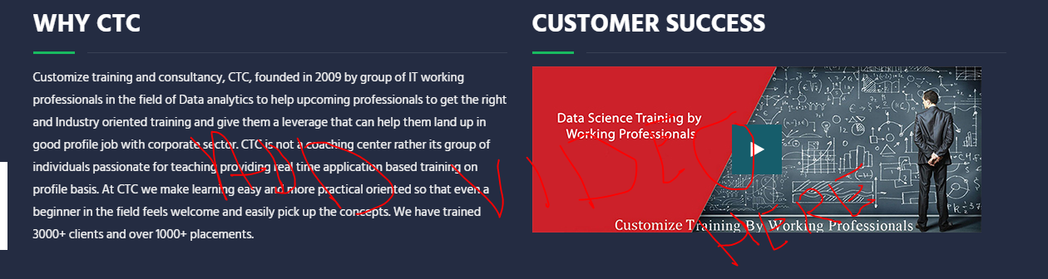

Next steps for you:

- Get in touch with us and get your orientation scheduled so that we can analyse your profile and let you know if the course is suitable for you and if it is aligned with your goals in general.

- Though self-study hours greatly depends on your current profile and gaol but in genera be prepared to put 250-400 Hrs of self-study to get the best outcome of this course.

What is Python and how it looks like
Python is a programming language and it is used to perform multiple things including
  - Data analytics
  - Predictive modelling, Machine learning
  - Artificial Intelligence, Data science, Deep learning
Watch below video to get more idea on Python.

